If it's far away, it's news, but if it's close at home, it's sociology. James Reston
Read more at: http://www.brainyquote.com/quotes/keywords/sociology.html

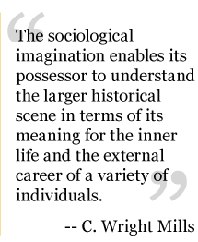
“The sociological imagination enable its possessor to understand the larger historical scene in terms of its meaning for the inner life and external career of a variety of individuals.” C. Wright Mills

We blame society, but we are society.

W.E.B. Du Bois—“Children learn more from what you are than what you teach.”

You are the creator of your own destiny.

Muhammad Ali-“Friendship is the hardest thing in the world to explain. It’s not something you learn in school. But if you haven’t learned the meaning of friendship, you really haven’t learned anything.”

Herbert Spencer-“No one can be perfectly free till all are free.”

Our lives can be greatly improved through a deeper understanding of individual and collective behavior.

Embrace your individuality. Love what you love without worrying about judgment.

Auguste Comte-“Men always forget that human happiness is a disposition of the mind and not a condition of circumstances.”

Earl Warren-“Many people consider the things government does for them to be social progress but they regard the things government does for others as socialism.”

Elizabeth Blackwell-“If society will not admit of woman’s free development, then society must be remodeled.”

Sometimes you need to step outside, get some air, and remind yourself of who you are and who you want to be.

