World History & Sociology
Distance Learning Procedures and Grading Policy
March 19th - May 26th 2020
Ms. Lawrence - dlawrence@eduhsd.k12.ca.us
Ponderosa High School

Delivery of Instruction

For the remainder of the academic year, curriculum will be delivered to students through the distance learning platform Edgenuity. Your World History course on Edgenuity began on Tuesday March 24th and will conclude on Tuesday May 26th. Initially the end date of the course was May 8th but this has been altered. The May 8th date was provided by the administration when it was believed we would return to school this year. The new end date of the course is now May 26th which is a closer reflection of the last day of instruction for the school year. This change has been updated in Edgenuity. This update will have a slight impact on your target progress but NO additional work has been added to the course.

Grading Weights

The social studies department at Ponderosa High School has determined that the distance learning portion of this semester will account for approximately 30% of the student’s overall semester grade. Your third quarter grades that you earned in the classroom will make up approximately 70% of your overall semester grade.

Please note that I will be using your “Relative Grade” from Edgenuity. When you log in you see your “Actual Grade” which is how you’ve performed on the work you’ve completed. Your “Relative Grade” takes into account your “Actual Grade” AND how far along you are in the course. When you finish the course in its entirety the two grades will be the same. Here is a screenshot example below from the course report.

For a video go to: https://www.youtube.com/watch?v=1FpSPSL1PD0&feature=youtu.be

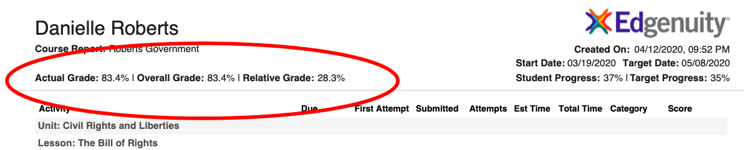

To get your final semester grade I will be creating gradebook categories on Aeries. These updates will be adjusted on Friday April 17th. When you finish the Edgenuity course OR on May 26th (whichever is first) I will enter your Edgenuity grade on Aeries. This final grade will be your semester grade for the course.

GRADEBOOK CATEGORIES & WEIGHTS ON AERIES
Assignment Type | Weight
Classroom grade  (3rd quarter grade including all homework, classwork, and tests/quizzes) | 70%
Edgenuity grade | 30%

Distance Learning Packets

Students without internet access have been provided with a packet of materials to be completed and submitted in May. This packet will be graded holistically and will account for 30% of the student’s overall second semester grade in place of Edgenuity. More information about how, when, and where to turn this packet in will be sent to you individually at a later date. Please keep an eye out for it!

Grading Policy

Due to the circumstances of this semester the school board has approved a different grading policy for spring semester. Students may take a traditional letter grade (A, B, C, etc.) OR may request a Pass “P” / No Mark “NM”. Unless you request it students will automatically be given a traditional letter grade. More information is coming soon from the administration about how to opt into Pass / No Mark.

For my class if you choose the Pass / No Mark option you would receive a Pass for a grade 60% and above and No Mark for a grade below 60%. For purposes of high school graduation requirements a Pass will earn you credit for the class but a No Mark will not earn you credit for the class. This means if you opt in and receive a No Mark you will have to retake this semester as it is a graduation requirement. Neither a Pass or a No Mark will impact your GPA like a traditional letter grade does.

Currently the state UC and CSU colleges have stated that they will accept Pass / No Marks for this graduating class because of the circumstances. However it is not a guarantee they will honor this for future classes or other colleges will either.

Due to the uncertainty I am strongly recommending that you stay with the traditional letter grading option. You have up until May 22nd to change your grading option for the semester.

